Studio Village Community Centre Program 2017
LATEST UPDATE July 2017
Monday | Start | Finish | Cost | 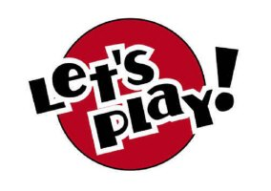  Contact
Move with Song | 9:15am | 10:15am | $20 Annual Fee | Nikki - 55298253
Indoor Bowls | 10:30am | 1:30pm | $3 | Allen Lewis - 5574 6146

Tuesday | Start | Finish | Cost | Contact
Helensvale Library Run | 9:00am | 10:30am | $4 | Office - 55298253
Yoga | 9:15am | 10:30am | $10 | Office - 55298253
Art | 11:00am | 2:00pm | $3 | Office - 55298253

Wednesday | Start | Finish | Cost | Contact
Village Kids Playgroup | 9:30am | 11:00am | $20 Annual Fee | Nikki – 55298253
Play and Learn | 11:30am | 12:30pm | $20 Annual Fee | Nikki – 55298253
Mystery Bus Tours | 8:30am | All Day | $25- 1st Wed | Office- 55298253
Community Dance Class – Junior (5-7 yrs) | 3:30pm | 4:15pm | $5 | Chloe- 0458935635
Community Dance Class – 8+ yrs | 4:15pm | 5:15pm | $5 | Chloe- 0458935635

Thursday | Start | Finish | Cost | Contact
Tai Chi | 8:30am | 9:30am | $15 | Gai – 0409 066 501 ($120 for 10 Lessons)
Play Pool Group | 9:00am | 11:00am | $2 | Office - 55298253
Shopping Bus- Fortnightly | 8:00am | 1:00pm | $6 | Office - 55298253
Craft | 11:00am | 2:00pm | $3 | Office - 55298253
Yoga “essence of living” | 6:15pm | 7:15pm | $2 | GCCC
Overeaters Anonymous | 6:30pm | 7:30pm | Don | Vanessa – 0403 234 765
Greenstone Health | 7:30pm | 8:30pm |  | Carl- 0450 628 016

Friday | Start | Finish | Cost | Contact
Yoga | 8:00am | 9:00am | $10 | Office – 5529 8253
Indoor Bowls | 9:30am | 1:00pm | $3 | Office – 55298253
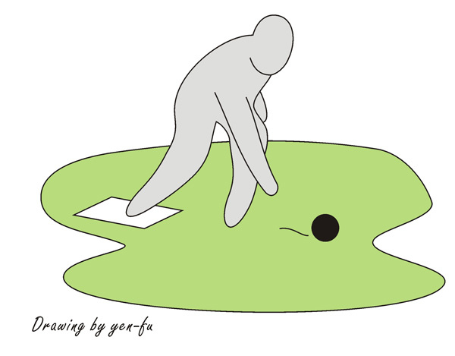

Saturday | Start | Finish | Cost | Contact
Tae Kwon Do | 9:00am | 11:00am | $13 | Gavin – 0423 349 742
Time slot available |  |  |  | Office – 55298253
Greenstone Health | 7:45pm | 8:45pm |  | Carl- 0450 628 016

Sunday | Start | Finish | Cost | Contact
Christ Generation Church | 9:30am | 1:30pm | TBA | Jaison – 0431 033 028

